Laborator 6 - UDP

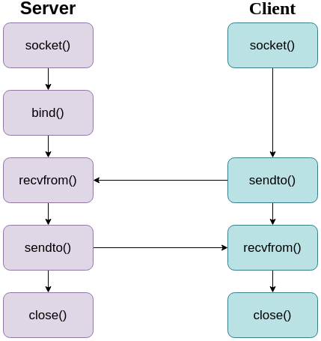

Server | Client
int s = socket(PF_INET, SOCK_DGRAM, 0);
if (s < 0)
perror(“Socket creation failed”);
struct sockaddr_in in;
in.sin_family = AF_INET;
in.sin_port = htons(12345);
in.sin_addr.s_addr = INADDR_ANY; | inet_aton(“127.0.0.1”, &in.sin_addr);
APEL SISTEM  bind(s, (struct sockaddr*) &in, sizeof(in)); | -----------
char buffer[LEN];  struct sockaddr_in client_info;  socklen_t length = sizeof(client_info);  int r = recvfrom(s, buffer, LEN, 0, (struct sockaddr*) &client_info, &length); | char buffer[LEN];  int s = sendto(s, buffer, LEN, 0, (struct sockaddr*) &in, sizeof(in));
sendto(...) | recvfrom(...)
close(s);

